CDAC MUMBAI

Concepts of Operating System Assignment 1

Problem 1: Read the instructions carefully and answer accordingly. If there is any need to insert some data then do that as well.

1. Navigate and List:
   1. Start by navigating to your home directory and list its contents. Then, move into a directory named "LinuxAssignment" if it exists; otherwise, create it.

Ans .

abhishek@Abhishek:~$ pwd

/home/abhishek

abhishek@Abhishek:~$ cd

abhishek@Abhishek:~$ ls

Feb25

abhishek@Abhishek:~$ mkdir LinuxAssignment

abhishek@Abhishek:~$ ls

Feb25 LinuxAssignment

abhishek@Abhishek:~$ cd LinuxAssignment/

abhishek@Abhishek:~/LinuxAssignment$

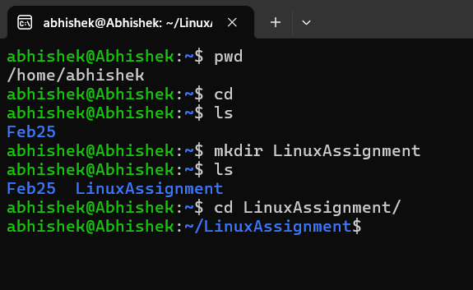

1. File Management:
   1. Inside the "LinuxAssignment" directory, create a new file named "file1.txt". Display its contents.

Ans .

abhishek@Abhishek:~/LinuxAssignment$ touch file1.txt

abhishek@Abhishek:~/LinuxAssignment$ ls

file1.txt

abhishek@Abhishek:~/LinuxAssignment$ nano file1.txt

abhishek@Abhishek:~/LinuxAssignment$ cat file1.txt

Abhishek Khursange

Cdac Mumbai

Feb25

abhishek@Abhishek:~/LinuxAssignment$

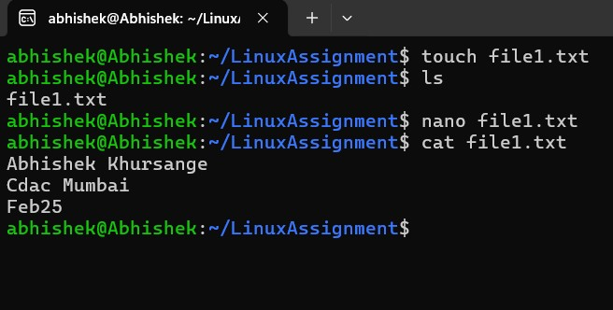

1. Directory Management:
   1. Create a new directory named "docs" inside the "LinuxAssignment" directory.

Ans.

abhishek@Abhishek:~/LinuxAssignment$ mkdir docs

abhishek@Abhishek:~/LinuxAssignment$ ls

docs file1.txt

abhishek@Abhishek:~/LinuxAssignment$ cd docs/

abhishek@Abhishek:~/LinuxAssignment/docs$

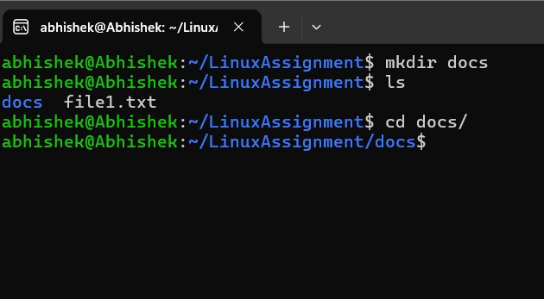

1. Copy and Move Files:
   1. Copy the "file1.txt" file into the "docs" directory and rename it to "file2.txt".

Ans.

abhishek@Abhishek:~/LinuxAssignment$ ls

docs file1.txt

abhishek@Abhishek:~/LinuxAssignment$ cp file1.txt docs

abhishek@Abhishek:~/LinuxAssignment$ cd docs/

abhishek@Abhishek:~/LinuxAssignment/docs$ ls

file1.txt

abhishek@Abhishek:~/LinuxAssignment/docs$ mv file1.txt file2.txt

abhishek@Abhishek:~/LinuxAssignment/docs$ ls

file2.txt

abhishek@Abhishek:~/LinuxAssignment/docs$

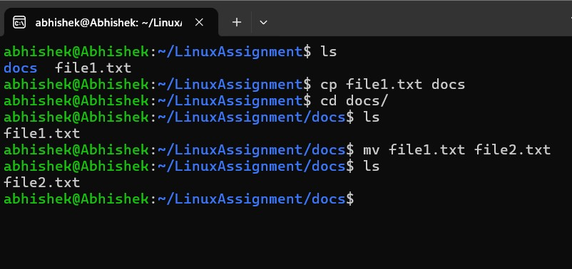

1. Permissions and Ownership:
   1. Change the permissions of "file2.txt" to allow read, write, and execute permissions for the owner and only read permissions for others. Then, change the owner of "file2.txt" to the current user.

Ans. abhishek@Abhishek:~/LinuxAssignment$ cd docs/

abhishek@Abhishek:~/LinuxAssignment/docs$ chown $(whoami) file2.txt

abhishek@Abhishek:~/LinuxAssignment/docs$ ls -l file2.txt

-rw-r--r-- 1 abhishek abhishek 37 Feb 27 22:50 file2.txt

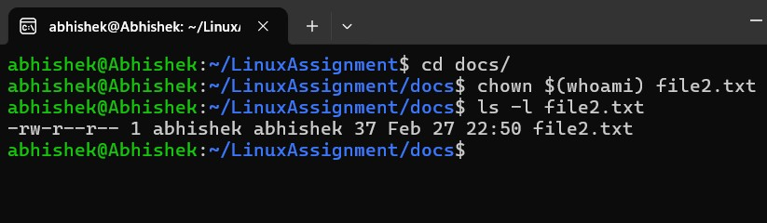abhishek@Abhishek:~/LinuxAssignment/docs$

1. Final Checklist:
   1. Finally, list the contents of the "LinuxAssignment" directory and the root directory to ensure that all operations were performed correctly.

Ans.

abhishek@Abhishek:~/LinuxAssignment$ ls -l ~/LinuxAssignment

total 8

drwxr-xr-x 2 abhishek abhishek 4096 Feb 27 22:51 docs

-rw-r--r-- 1 abhishek abhishek 37 Feb 27 22:44 file1.txt

abhishek@Abhishek:~/LinuxAssignment$ ls -l /

total 2436

lrwxrwxrwx 1 root root 7 Jan 7 03:05 bin -> usr/bin

drwxr-xr-x 2 root root 4096 Apr 18 2022 boot

drwxr-xr-x 16 root root 3580 Feb 27 22:22 dev

drwxr-xr-x 81 root root 4096 Feb 27 22:22 etc

drwxr-xr-x 5 root root 4096 Feb 27 22:20 home

-rwxrwxrwx 1 root root 2424984 Feb 12 06:29 init

lrwxrwxrwx 1 root root 7 Jan 7 03:05 lib -> usr/lib

lrwxrwxrwx 1 root root 9 Jan 7 03:05 lib32 -> usr/lib32

lrwxrwxrwx 1 root root 9 Jan 7 03:05 lib64 -> usr/lib64

lrwxrwxrwx 1 root root 10 Jan 7 03:05 libx32 -> usr/libx32

drwx------ 2 root root 16384 Feb 27 22:06 lost+found

drwxr-xr-x 2 root root 4096 Jan 7 03:05 media

drwxr-xr-x 8 root root 4096 Feb 27 22:06 mnt

drwxr-xr-x 2 root root 4096 Jan 7 03:05 opt

dr-xr-xr-x 173 root root 0 Feb 27 22:22 proc

drwx------ 3 root root 4096 Feb 27 22:15 root

drwxr-xr-x 18 root root 540 Feb 27 22:22 run

lrwxrwxrwx 1 root root 8 Jan 7 03:05 sbin -> usr/sbin

drwxr-xr-x 2 root root 4096 Feb 27 22:06 snap

drwxr-xr-x 2 root root 4096 Jan 7 03:05 srv

dr-xr-xr-x 11 root root 0 Feb 27 22:06 sys

drwxrwxrwt 11 root root 4096 Feb 27 22:56 tmp

drwxr-xr-x 14 root root 4096 Jan 7 03:05 usr

drwxr-xr-x 13 root root 4096 Jan 7 03:07 var

abhishek@Abhishek:~/LinuxAssignment$

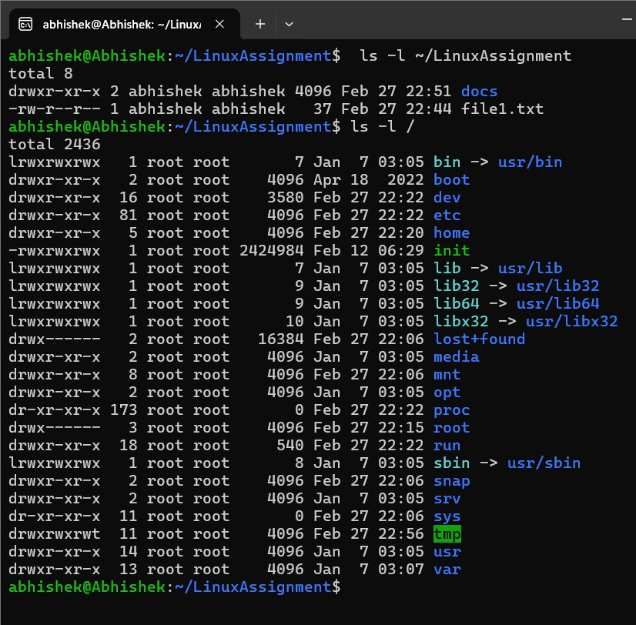

1. File Searching:
   1. Search for all files with the extension ".txt" in the current directory and its subdirectories.

Ans.

abhishek@Abhishek:~/LinuxAssignment$ find . -type f -name "*.txt"

./docs/file2.txt

./file1.txt

abhishek@Abhishek:~/LinuxAssignment$

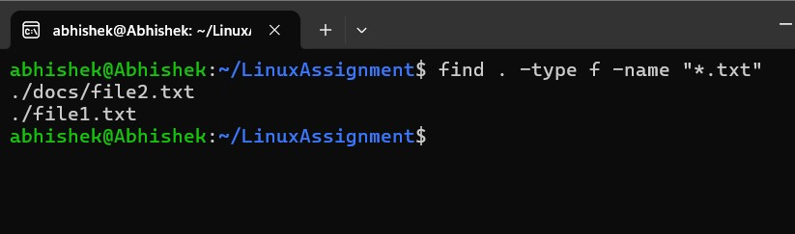

* 1. Display lines containing a specific word in a file (provide a file name and the specific word to search).

Ans. abhishek@Abhishek:~/LinuxAssignment$ grep "Abhishek" file1.txt

Abhishek Khursange

abhishek@Abhishek:~/LinuxAssignment$

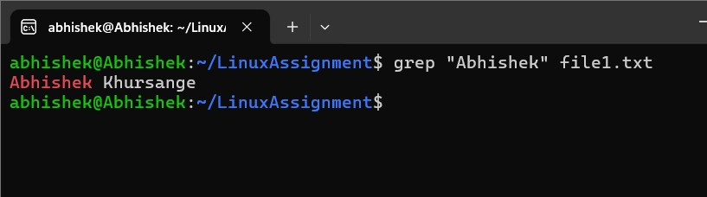

1. System Information:
   1. Display the current system date and time.

Ans.

abhishek@Abhishek:~/LinuxAssignment$ date

Thu Feb 27 23:17:19 IST 2025

abhishek@Abhishek:~/LinuxAssignment$ date +"%Y-%m-%d"

2025-02-27

abhishek@Abhishek:~/LinuxAssignment$ date +"%H:%M:%S"

23:18:11

abhishek@Abhishek:~/LinuxAssignment$ date +"%A, %B %d, %Y %I:%M %p"

Thursday, February 27, 2025 11:18 PM

abhishek@Abhishek:~/LinuxAssignment$

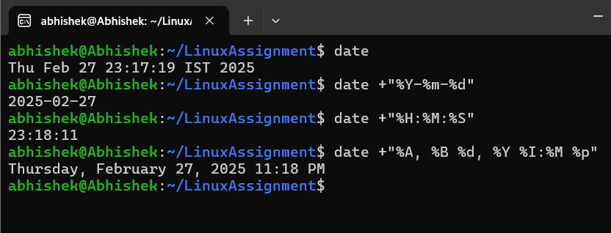

1. Networking:
   1. Display the IP address of the system.

Ans.

abhishek@Abhishek:~/LinuxAssignment$ ipconfig.exe

Windows IP Configuration

Ethernet adapter vEthernet (WSL (Hyper-V firewall)):

Connection-specific DNS Suffix . :

Link-local IPv6 Address . . . . . : fe80::ab7d:9aac:7fdc:c9bd%30

IPv4 Address. . . . . . . . . . . : 172.17.224.1

Subnet Mask . . . . . . . . . . . : 255.255.240.0

Default Gateway . . . . . . . . . :

Wireless LAN adapter Local Area Connection* 1:

Media State . . . . . . . . . . . : Media disconnected

Connection-specific DNS Suffix . :

Wireless LAN adapter Local Area Connection* 2:

Media State . . . . . . . . . . . : Media disconnected

Connection-specific DNS Suffix . :

Wireless LAN adapter Wi-Fi:

Connection-specific DNS Suffix . :

IPv6 Address. . . . . . . . . . . : 2409:4042:2c88:c3b8:9a9a:1813:cec0:9cf

Temporary IPv6 Address. . . . . . : 2409:4042:2c88:c3b8:d0da:39c8:5c6f:14f

Link-local IPv6 Address . . . . . : fe80::11a0:e440:e18e:a9e8%13

IPv4 Address. . . . . . . . . . . : 192.168.82.15

Subnet Mask . . . . . . . . . . . : 255.255.255.0

Default Gateway . . . . . . . . . : fe80::be9d:4eff:fe23:e8fd%13

fe80::5cd7:69ff:fe37:cf7f%13

192.168.82.154

Ethernet adapter Bluetooth Network Connection:

Media State . . . . . . . . . . . : Media disconnected

Connection-specific DNS Suffix . :

abhishek@Abhishek:~/LinuxAssignment$

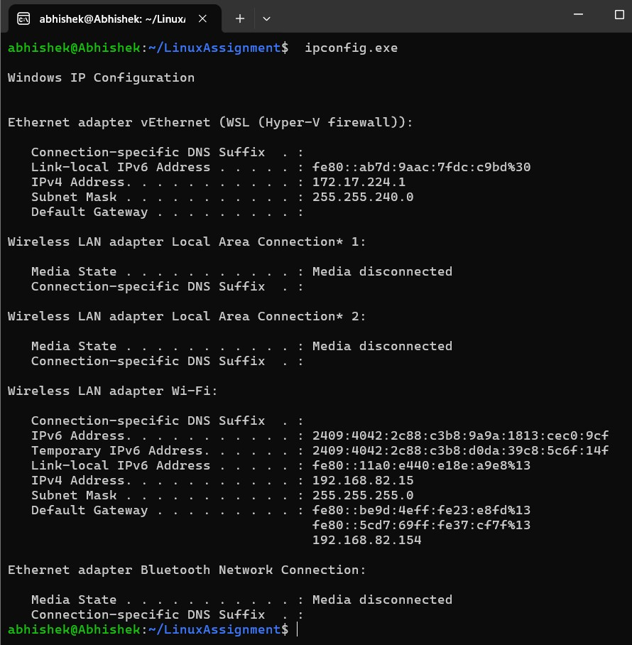

* 1. Ping a remote server to check connectivity (provide a remote server address to ping). j) File Compression:

Ans.

abhishek@Abhishek:~/LinuxAssignment$ ping -c 4 google.com

PING google.com (142.250.67.206) 56(84) bytes of data.

64 bytes from bom12s08-in-f14.1e100.net (142.250.67.206): icmp_seq=1 ttl=110 time=89.3 ms

64 bytes from bom12s08-in-f14.1e100.net (142.250.67.206): icmp_seq=2 ttl=110 time=64.5 ms

64 bytes from bom12s08-in-f14.1e100.net (142.250.67.206): icmp_seq=3 ttl=110 time=105 ms

64 bytes from bom12s08-in-f14.1e100.net (142.250.67.206): icmp_seq=4 ttl=110 time=79.5 ms

--- google.com ping statistics ---

4 packets transmitted, 4 received, 0% packet loss, time 3238ms

rtt min/avg/max/mdev = 64.535/84.521/104.736/14.628 ms

abhishek@Abhishek:~/LinuxAssignment$ ping -c 4 nasa.com

PING nasa.com (185.53.177.52) 56(84) bytes of data.

64 bytes from 185.53.177.52 (185.53.177.52): icmp_seq=1 ttl=42 time=157 ms

64 bytes from 185.53.177.52 (185.53.177.52): icmp_seq=2 ttl=42 time=155 ms

64 bytes from 185.53.177.52 (185.53.177.52): icmp_seq=3 ttl=42 time=161 ms

64 bytes from 185.53.177.52 (185.53.177.52): icmp_seq=4 ttl=42 time=183 ms

--- nasa.com ping statistics ---

4 packets transmitted, 4 received, 0% packet loss, time 3205ms

rtt min/avg/max/mdev = 155.114/163.924/182.961/11.208 ms

abhishek@Abhishek:~/LinuxAssignment$ ping -c 4 jio.com

PING jio.com (49.40.8.203) 56(84) bytes of data.

--- jio.com ping statistics ---

4 packets transmitted, 0 received, 100% packet loss, time 3458ms

abhishek@Abhishek:~/LinuxAssignment$

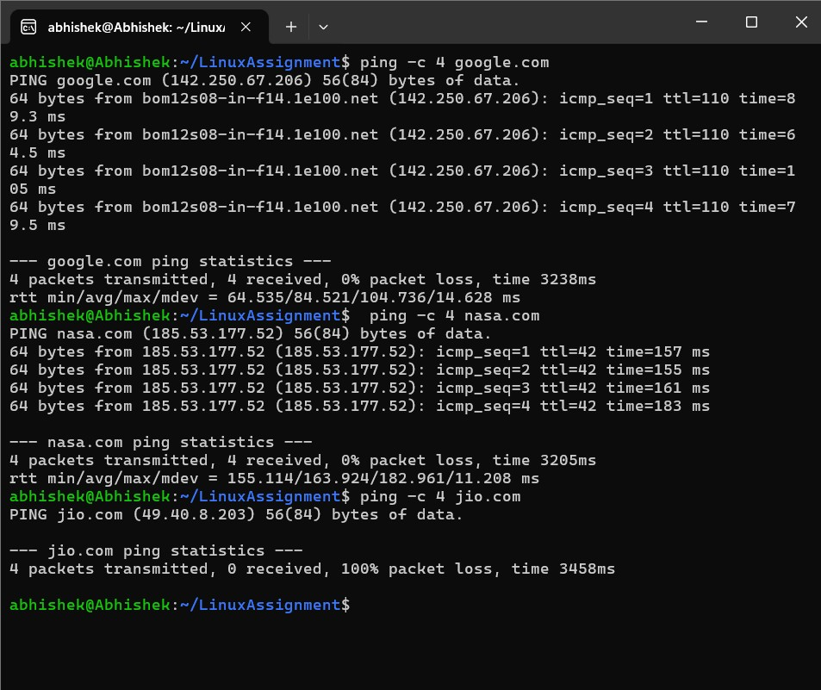

j) File Compression:

* 1. Compress the "docs" directory into a zip file.

Ans.

abhishek@Abhishek:~/LinuxAssignment$ ls

docs file1.txt

abhishek@Abhishek:~/LinuxAssignment$ zip -r docs.zip docs

Command 'zip' not found, but can be installed with:

sudo apt install zip

abhishek@Abhishek:~/LinuxAssignment$ sudo apt install zip

[sudo] password for abhishek:

Reading package lists... Done

Building dependency tree... Done

Reading state information... Done

The following additional packages will be installed:

unzip

The following NEW packages will be installed:

unzip zip

0 upgraded, 2 newly installed, 0 to remove and 0 not upgraded.

Need to get 350 kB of archives.

After this operation, 930 kB of additional disk space will be used.

Do you want to continue? [Y/n] y

Get:1 http://archive.ubuntu.com/ubuntu jammy-updates/main amd64 unzip amd64 6.0-26ubuntu3.2 [175 kB]

Get:2 http://archive.ubuntu.com/ubuntu jammy/main amd64 zip amd64 3.0-12build2 [176 kB]

Fetched 350 kB in 3s (134 kB/s)

Selecting previously unselected package unzip.

(Reading database ... 42578 files and directories currently installed.)

Preparing to unpack .../unzip_6.0-26ubuntu3.2_amd64.deb ...

Unpacking unzip (6.0-26ubuntu3.2) ...

Selecting previously unselected package zip.

Preparing to unpack .../zip_3.0-12build2_amd64.deb ...

Unpacking zip (3.0-12build2) ...

Setting up unzip (6.0-26ubuntu3.2) ...

Setting up zip (3.0-12build2) ...

Processing triggers for man-db (2.10.2-1) ...

abhishek@Abhishek:~/LinuxAssignment$ zip -r docs.zip docs

adding: docs/ (stored 0%)

adding: docs/file2.txt (stored 0%)

abhishek@Abhishek:~/LinuxAssignment$ ls

docs docs.zip file1.txt

abhishek@Abhishek:~/LinuxAssignment$

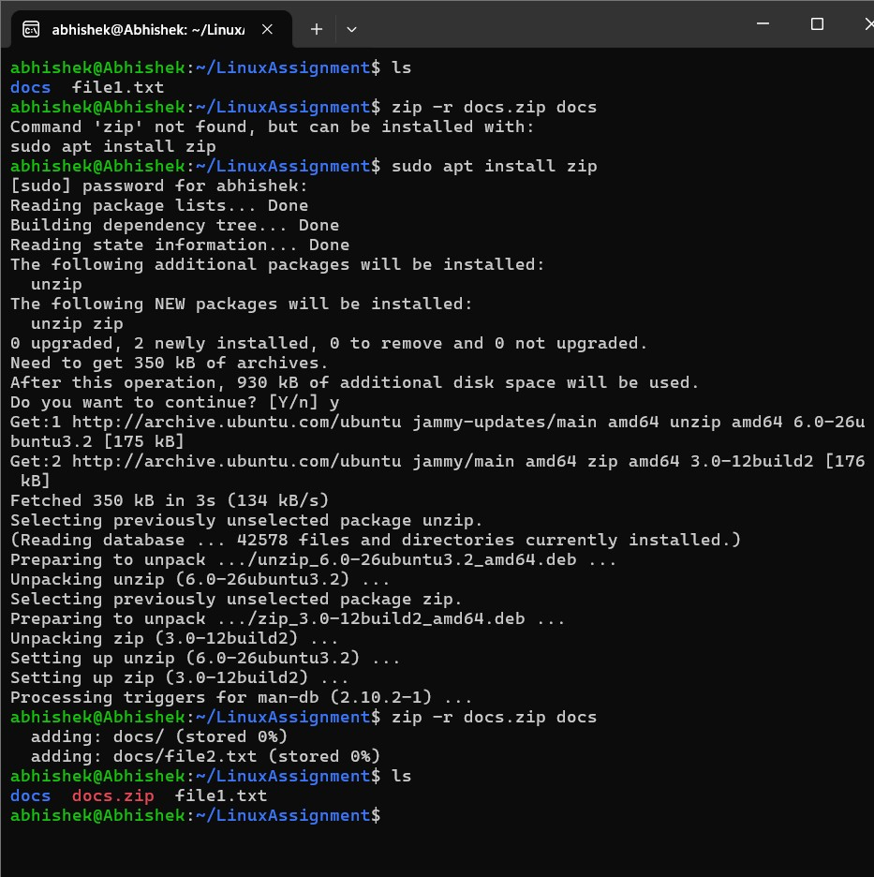

* 1. Extract the contents of the zip file into a new directory.

Ans.

abhishek@Abhishek:~/LinuxAssignment$ ls

docs docs.zip file1.txt

abhishek@Abhishek:~/LinuxAssignment$ mkdir docs1

abhishek@Abhishek:~/LinuxAssignment$ ls

docs docs.zip docs1 file1.txt

abhishek@Abhishek:~/LinuxAssignment$ unzip docs.zip -d docs1

Archive: docs.zip

creating: docs1/docs/

extracting: docs1/docs/file2.txt

abhishek@Abhishek:~/LinuxAssignment$ ls

docs docs.zip docs1 file1.txt

abhishek@Abhishek:~/LinuxAssignment$ cd docs1

abhishek@Abhishek:~/LinuxAssignment/docs1$ ls

docs

abhishek@Abhishek:~/LinuxAssignment/docs1$ cd docs/

abhishek@Abhishek:~/LinuxAssignment/docs1/docs$ ls

file2.txt

abhishek@Abhishek:~/LinuxAssignment/docs1/docs$

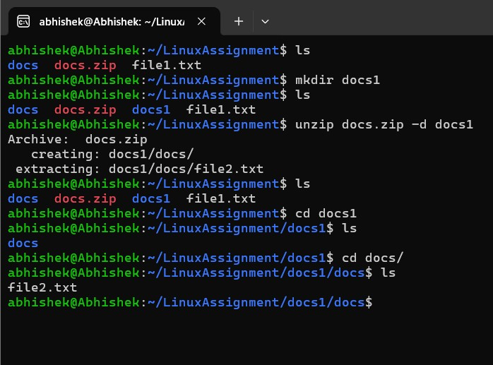

k) File Editing:

1. Open the "file1.txt" file in a text editor and add some text to it.

Ans.

abhishek@Abhishek:~/LinuxAssignment$ ls

docs docs.zip docs1 file1.txt

abhishek@Abhishek:~/LinuxAssignment$ nano file1.txt

abhishek@Abhishek:~/LinuxAssignment$ cat file1.txt

Abhishek Khursange

Cdac Mumbai

Feb25

Books are man's best friends. Books are portable and so they are easy to carry around. And so books can be read at any time night or day, while travelling on a bus or train or flight, and at meal time too. Books are published in many Languages and in varied genres. There arebooks in fiction and non-fiction categories. Each of these categories has many different sections and genres, and there are many thousands of titles in each type. Every book title has an International Standard Book Number (ISBN) that is unique to it, and helps in identifying it. Today books are available as web versions too so that they can be read on the internet. They may be read on the modern kindle or on the computer. And books are available in audio versions too so that you can hear an entire book being read out aloud.

abhishek@Abhishek:~/LinuxAssignment$

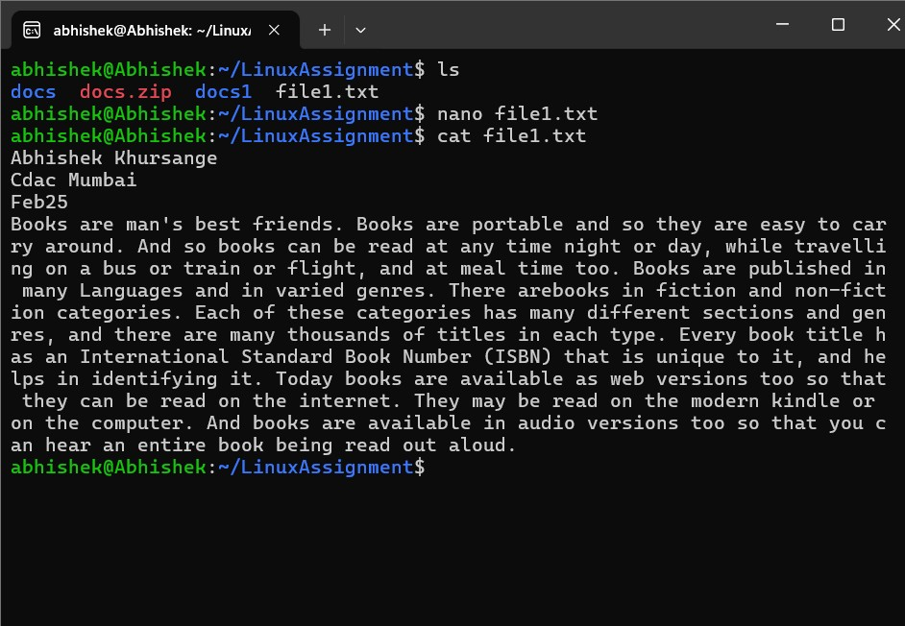

b.Replace a specific word in the "file1.txt" file with another word (provide the original word and the word to replace it with).

Ans.

abhishek@Abhishek:~/LinuxAssignment$ ls

docs docs.zip docs1 file1.txt

abhishek@Abhishek:~/LinuxAssignment$ nano file1.txt

abhishek@Abhishek:~/LinuxAssignment$ cat file1.txt

Abhishek Khursange

Cdac Mumbai

Feb25

Books are man's best friends. Books are portable and so they are easy to carry around. And so books can be read at any time night or day, while travelling on a bus or train or flight, and at meal time too. Books are published in many Languages and in varied genres. There arebooks in fiction and non-fiction categories. Each of these categories has many different sections and genres, and there are many thousands of titles in each type. Every book title has an International Standard Book Number (ISBN) that is unique to it, and helps in identifying it. Today books are available as web versions too so that they can be read on the internet. They may be read on the modern kindle or on the computer. And books are available in audio versions too so that you can hear an entire book being read out aloud.

hello Good night Guys!!!

abhishek@Abhishek:~/LinuxAssignment$ sed -i 's/Books/Food/g' file1.txt

abhishek@Abhishek:~/LinuxAssignment$ ls

docs docs.zip docs1 file1.txt

abhishek@Abhishek:~/LinuxAssignment$ cat file1.txt

Abhishek Khursange

Cdac Mumbai

Feb25

Food are man's best friends. Food are portable and so they are easy to carry around. And so books can be read at any time night or day, while travelling on a bus or train or flight, and at meal time too. Food are published in many Languages and in varied genres. There arebooks in fiction and non-fiction categories. Each of these categories has many different sections and genres, and there are many thousands of titles in each type. Every book title has an International Standard Book Number (ISBN) that is unique to it, and helps in identifying it. Today books are available as web versions too so that they can be read on the internet. They may be read on the modern kindle or on the computer. And books are available in audio versions too so that you can hear an entire book being read out aloud.

hello Good night Guys!!!

abhishek@Abhishek:~/LinuxAssignment$

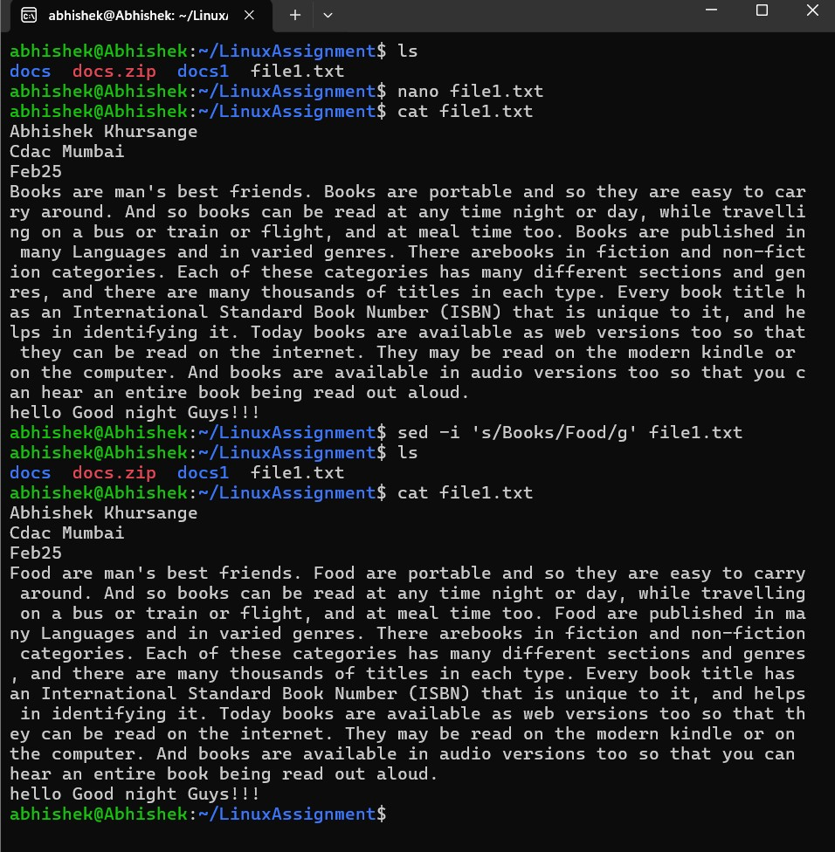

Problem 2: Read the instructions carefully and answer accordingly. If there is any need to insert some data then do that as well.

1. Suppose you have a file named "data.txt" containing important information. Display the first 10 lines of this file to quickly glance at its contents using a command.

Ans.

abhishek@Abhishek:~/LinuxAssignment$ ls

docs docs.zip docs1 file1.txt

abhishek@Abhishek:~/LinuxAssignment$ touch data.txt

abhishek@Abhishek:~/LinuxAssignment$ nano data.txt

abhishek@Abhishek:~/LinuxAssignment$ head -10 data.txt

apple, blue, 27, dog, mountain

sun, red, 12, cat, river

book, green, 45, bird, forest

car, yellow, 8, fish, ocean

house, purple, 62, rabbit, desert

tree, orange, 19, horse, field

computer, brown, 33, mouse, city

phone, pink, 51, snake, jungle

chair, gray, 7, bear, cave

table, white, 22, lion, savanna

abhishek@Abhishek:~/LinuxAssignment$

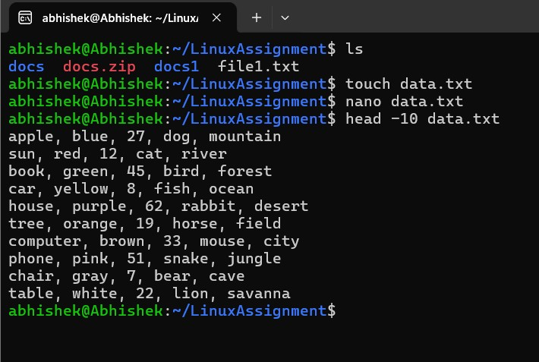

1. Now, to check the end of the file for any recent additions, display the last 5 lines of "data.txt" using another command.

Ans.

abhishek@Abhishek:~/LinuxAssignment$ ls

data.txt docs docs.zip docs1 file1.txt

abhishek@Abhishek:~/LinuxAssignment$ tail -5 data.txt

tree, orange, 19, horse, field

computer, brown, 33, mouse, city

phone, pink, 51, snake, jungle

chair, gray, 7, bear, cave

table, white, 22, lion, savanna

abhishek@Abhishek:~/LinuxAssignment$

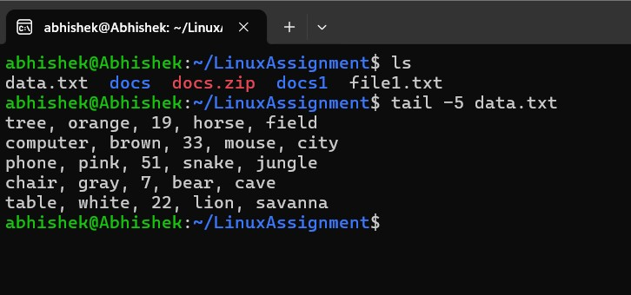

1. In a file named "numbers.txt," there are a series of numbers. Display the first 15 lines of this file to analyze the initial data set.

Ans.

abhishek@Abhishek:~/LinuxAssignment$ touch number.txt

abhishek@Abhishek:~/LinuxAssignment$ nano number.txt

abhishek@Abhishek:~/LinuxAssignment$ head -n 15 number.txt

1

2

3

4

5

6

7

8

9

10

11

12

13

14

15

abhishek@Abhishek:~/LinuxAssignment$

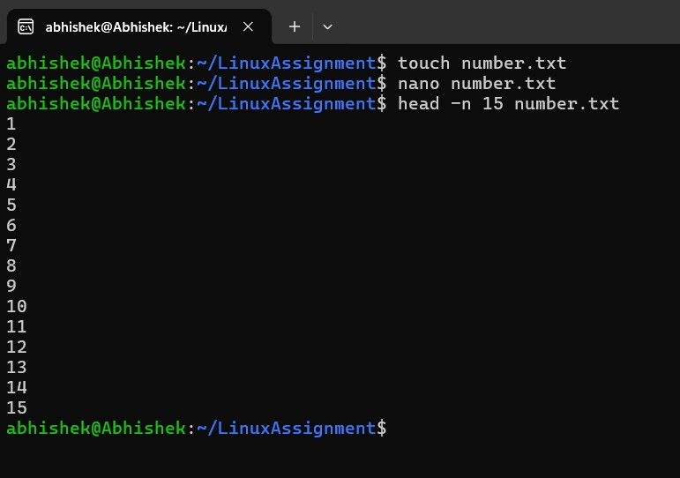

1. To focus on the last few numbers of the dataset, display the last 3 lines of "numbers.txt".

Ans.

abhishek@Abhishek:~/LinuxAssignment$ tail -n 3 number.txt

18

19

20

abhishek@Abhishek:~/LinuxAssignment$

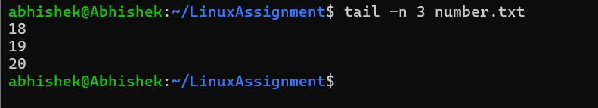

1. Imagine you have a file named "input.txt" with text content. Use a command to translate all lowercase letters to uppercase in "input.txt" and save the modified text in a new file named "output.txt."

Ans.

abhishek@Abhishek:~/LinuxAssignment$ touch input.txt

abhishek@Abhishek:~/LinuxAssignment$ ls

data.txt docs docs.zip docs1 file1.txt input.txt number.txt

abhishek@Abhishek:~/LinuxAssignment$ nano input.txt

abhishek@Abhishek:~/LinuxAssignment$ cat input.txt

this is a test.

hello world.

some more cricket.

1569 test words.

abhishek@Abhishek:~/LinuxAssignment$ tr '[:lower:]' '[:upper:]' < input.txt > output.txt

abhishek@Abhishek:~/LinuxAssignment$ ls

data.txt docs.zip file1.txt number.txt

docs docs1 input.txt output.txt

abhishek@Abhishek:~/LinuxAssignment$ cat output.txt

THIS IS A TEST.

HELLO WORLD.

SOME MORE CRICKET.

1569 TEST WORDS.

abhishek@Abhishek:~/LinuxAssignment$

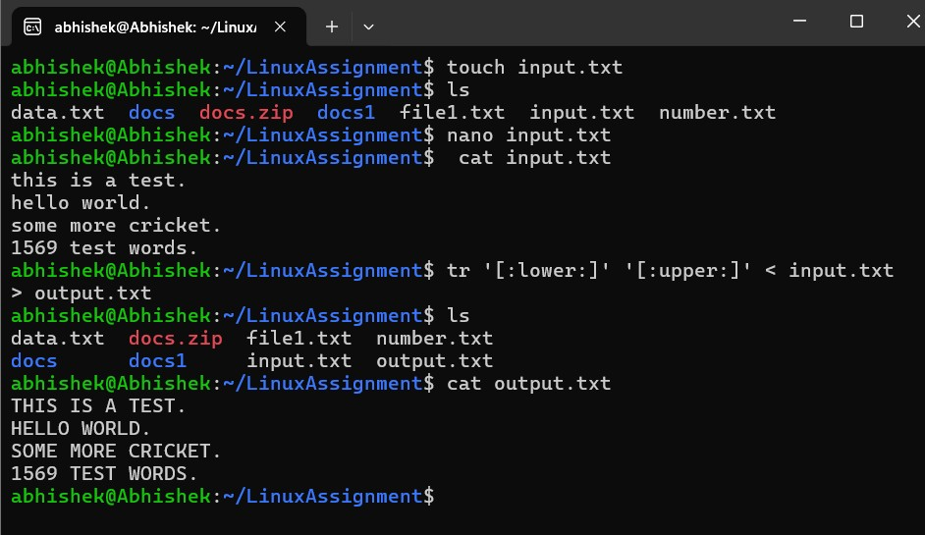

1. In a file named "duplicate.txt," there are several lines of text, some of which are duplicates. Use a command to display only the unique lines from "duplicate.txt."

Ans.

abhishek@Abhishek:~/LinuxAssignment$ touch duplicate.txt

abhishek@Abhishek:~/LinuxAssignment$ nano duplicate.txt

abhishek@Abhishek:~/LinuxAssignment$ cat duplicate.txt

alpha

beta

gamma

alpha

delta

epsilon

beta

gamma

gamma

alpha

epsilon

delta

beta

abhishek@Abhishek:~/LinuxAssignment$ sort duplicate.txt | uniq

alpha

beta

delta

epsilon

gamma

abhishek@Abhishek:~/LinuxAssignment$

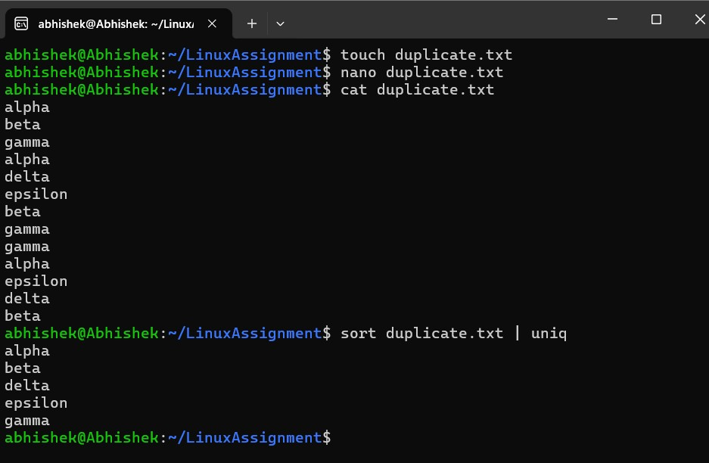

1. In a file named "fruit.txt," there is a list of fruits, but some fruits are repeated. Use a command to display each unique fruit along with the count of its occurrences in "fruit.txt."

Ans.

abhishek@Abhishek:~/LinuxAssignment$ touch fruit.txt

abhishek@Abhishek:~/LinuxAssignment$ nano fruit.txt

abhishek@Abhishek:~/LinuxAssignment$ cat fruit.txt

apple

banana

apple

orange

banana

grape

apple

grape

mango

orange

mango

banana

pineapple

pear

kiwi

apple

pear

kiwi

grape

melon

melon

banana

abhishek@Abhishek:~/LinuxAssignment$ sort fruit.txt | uniq -c

4 apple

4 banana

3 grape

2 kiwi

2 mango

2 melon

2 orange

2 pear

1 pineapple

abhishek@Abhishek:~/LinuxAssignment$

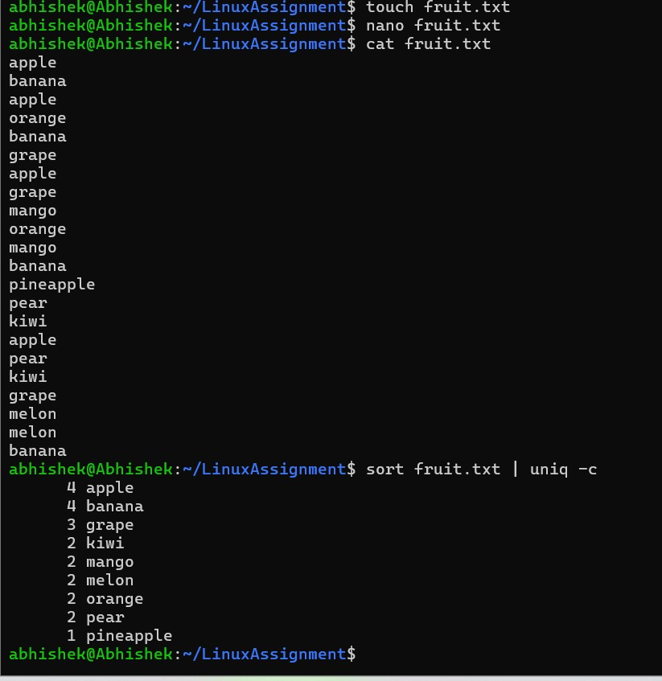

Submission Guidelines:

• Document each step of your solution and any challenges faced.

•

Upload it on your GitHub repository

Additional Tips:

•

Experiment with different options and parameters of each command to explore their

functionalities.